“Celebrate the Possibilities”

Special needs livestock show
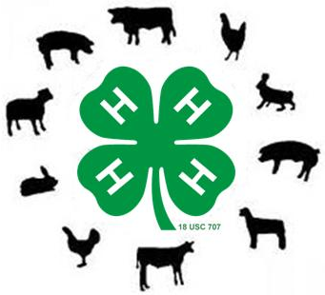
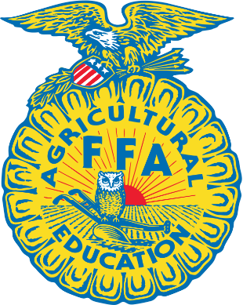
September 10th, 2016
9am-12pm
Myers Park, McKinney
Event Schedule:
8:30-9am Check in and meet volunteers
9-9:15am Opening ceremony
9:15am-12pm Livestock show

- Collin County 4-H and FFA members are offering an opportunity for special needs children ages 5-18 to participate in a livestock show
- Participants will have the opportunity to “Celebrate the Possibilities” by competing in a livestock show leading goats and sheep, brushing miniature horses, feeding chicks, gardening station and see pigs, rabbits, dogs and more!
- The show is free to special needs children, but registration required by August 19, 2016
- 4-H and FFA members and parents -Register to volunteer at http://www.signupgenius.com/go/20f084caeab2ba02-celebrate
- For questions contact Amanda Parks at 972.548.4233 or Amanda.parks@ag.tamu.edu

Learn More and Download forms at https://www.facebook.com/Celebratethepossibilities/?fref=ts

